

**Module Name:** Web Applications and AI

**Module Code:** 7051CEM

**Student ID:** 14962877

**Demo Video Link:**[**https://drive.google.com/file/d/1yfjI12qDWq-iqBOQMr0LP4-BbB5pFK3z/view?usp=sharing**](https://drive.google.com/file/d/1yfjI12qDWq-iqBOQMr0LP4-BbB5pFK3z/view?usp=sharing)

**APPLICATION DESIGN**

**Design Patterns**

**MVC (Model-View-Controller)**: The MVC (Model-View-Controller) design pattern is a widely-used architectural pattern for developing web applications. It divides the application into three interconnected components, each responsible for different aspects of the application’s operation. This separation enhances the modularity of the application, making it easier to manage, test, and scale.

**Model**: The application's data and business logic are represented by the model. It is in charge of gathering, analysing, and preserving data.

In my web application, the Model could be represented by classes that handle database operations, such as ItemDAO for managing item data or UserDAO for handling user information and UserItemsDAO for handling users and items details, ExchangeRequestsDAO for handling the Exchange requests of different users.

**View:** The View is responsible for displaying the data to the user and presenting the user interface (UI). It is concerned with how data is presented and allows the user to interact with the application.

JSP (JavaServer Pages) files in a web application, such as list-items.jsp ,add-listing, login.jsp, register.jsp, update-listing.jsp and view-requests.jsp are views that present data to the user and accept user inputs

**Controller**: The Controller acts as an intermediary between the Model and the View. It processes user input, interacts with the Model, and updates the View based on the Model’s state. Handles user input and interactions (e.g., Servlets like AddListingServlet and UpdateRequestServlet,ListItemServlet, DeleteServlet, CreateRequestServlet and others).

* **DAO (Data Access Object)**: The DAO pattern is used to abstract and encapsulate all interactions with the data source. This separation helps manage database operations separately from the rest of the application logic.
* **Singleton Pattern**: Used in cases where a single instance of a class is needed (e.g., managing a single database connection pool).

**Entity-Relationship (ER) Diagram**

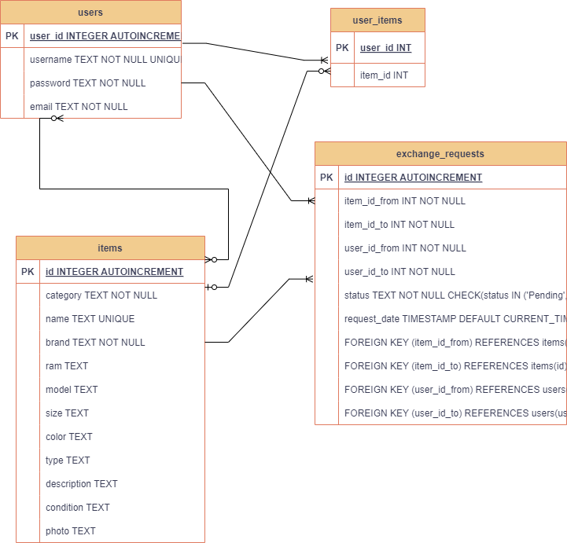

**Wireframes and Sketches**

* **Wireframes**: Illustrate the layout of your web pages (e.g., list-items.jsp, update-request.jsp, add-listing.jsp).

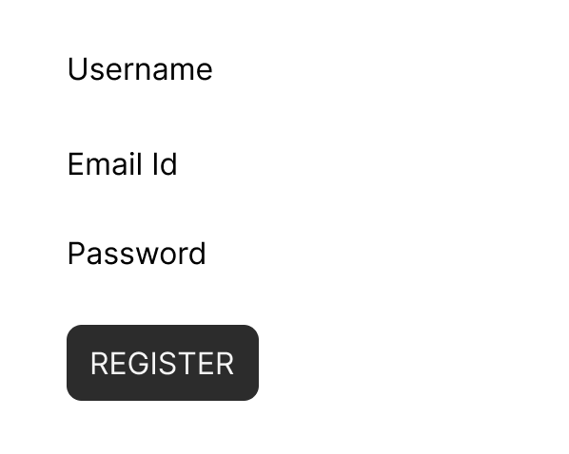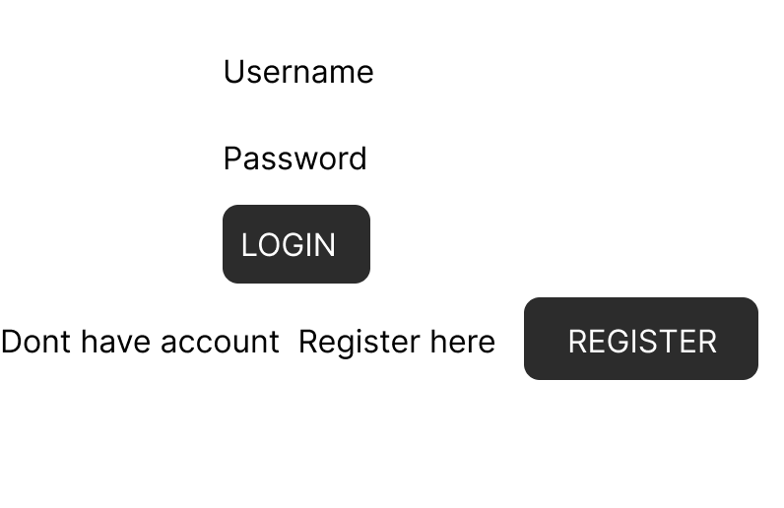

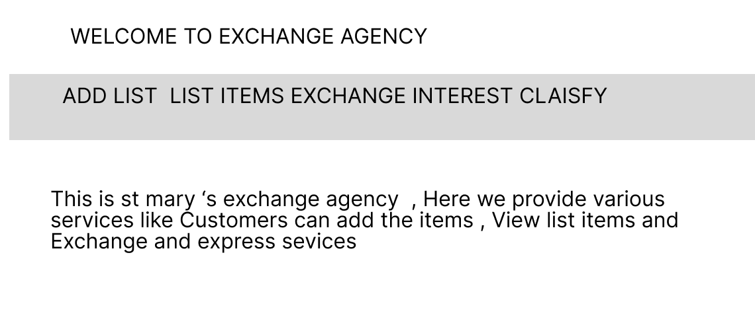

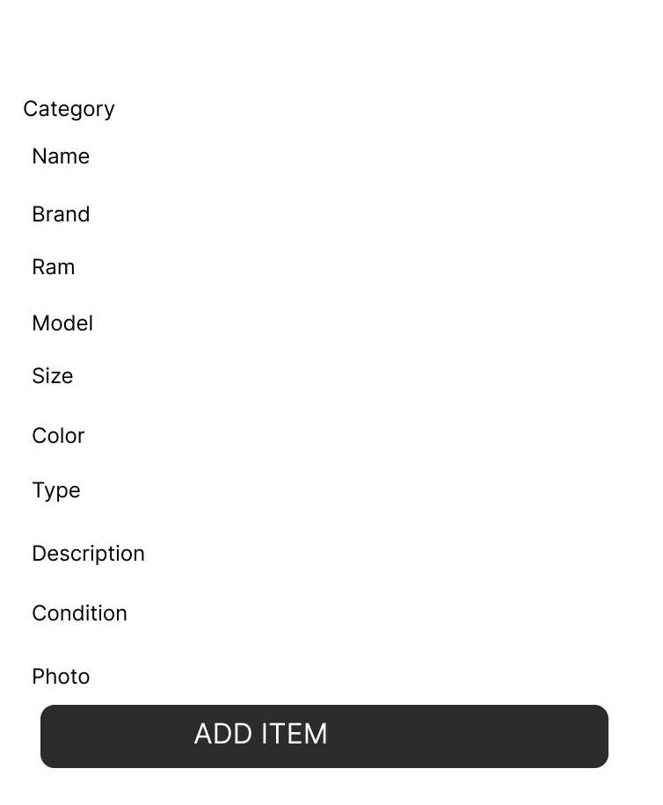

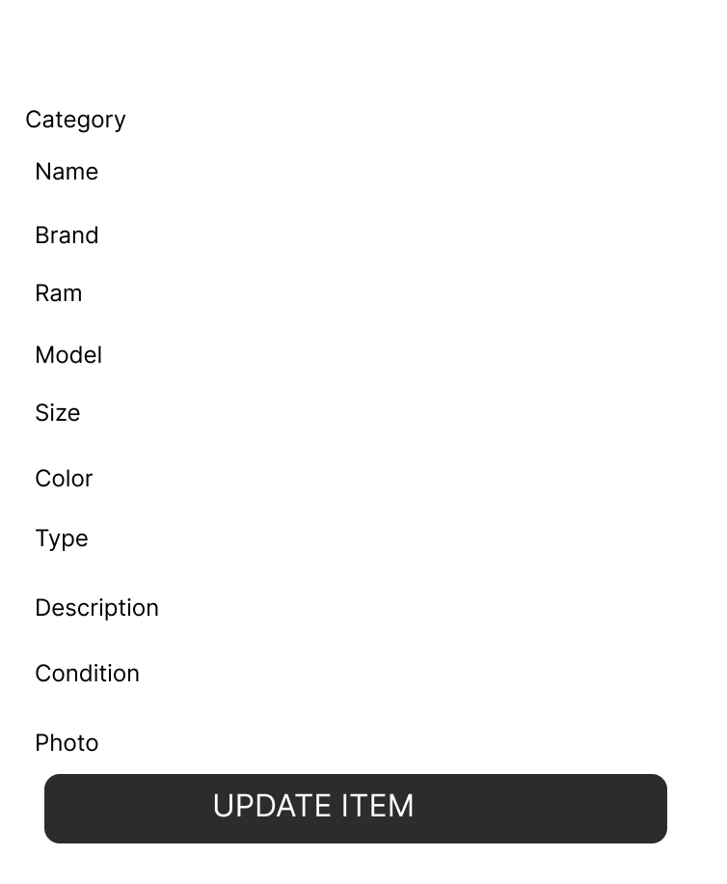

SKETCHES:

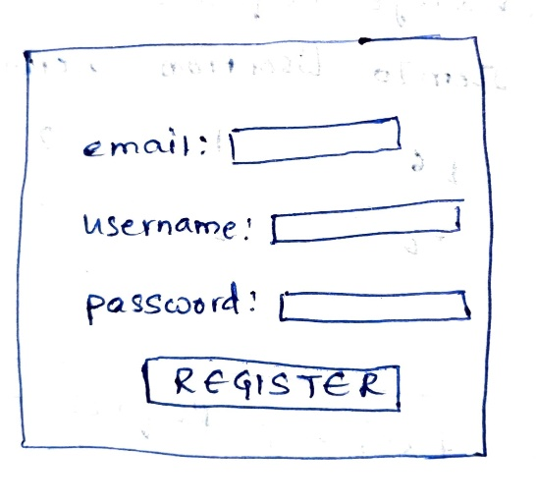 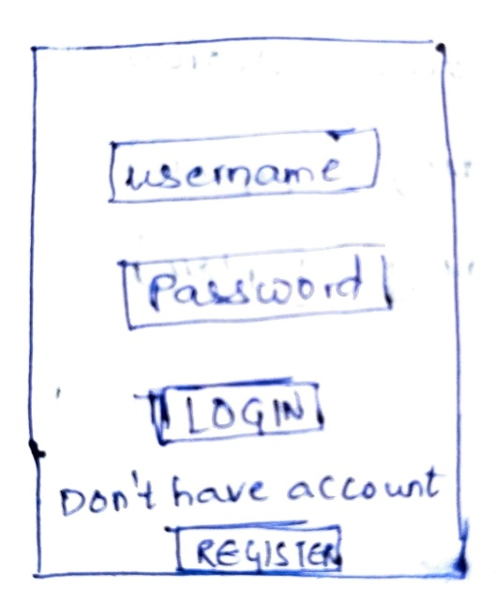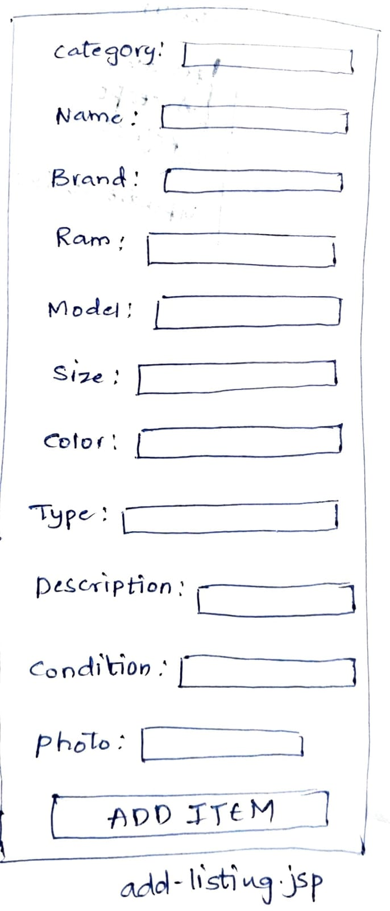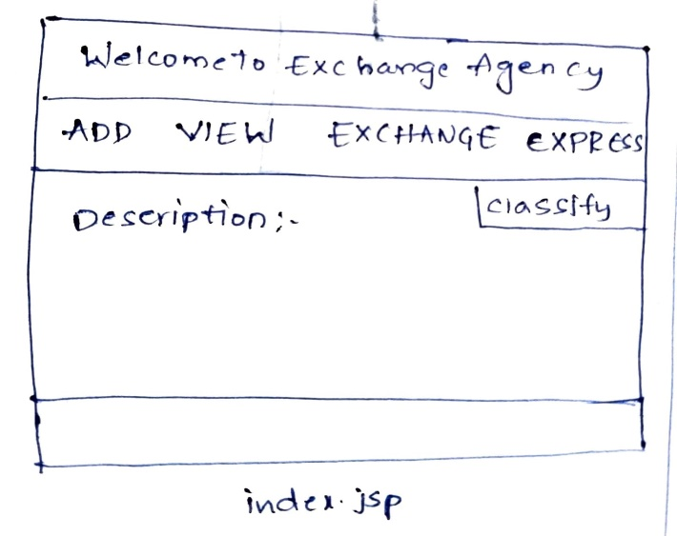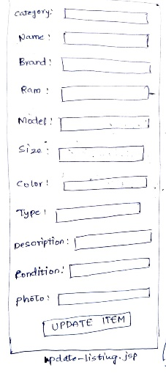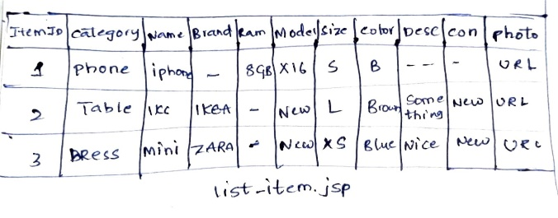

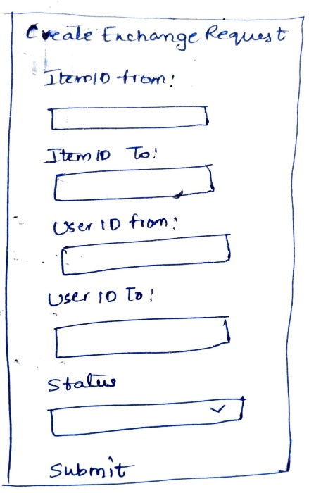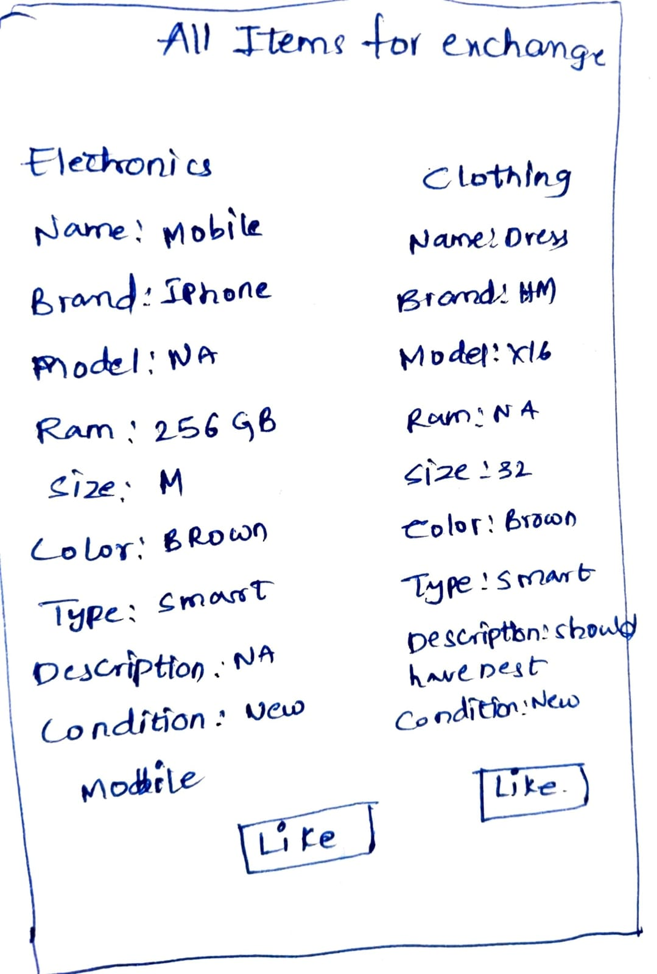

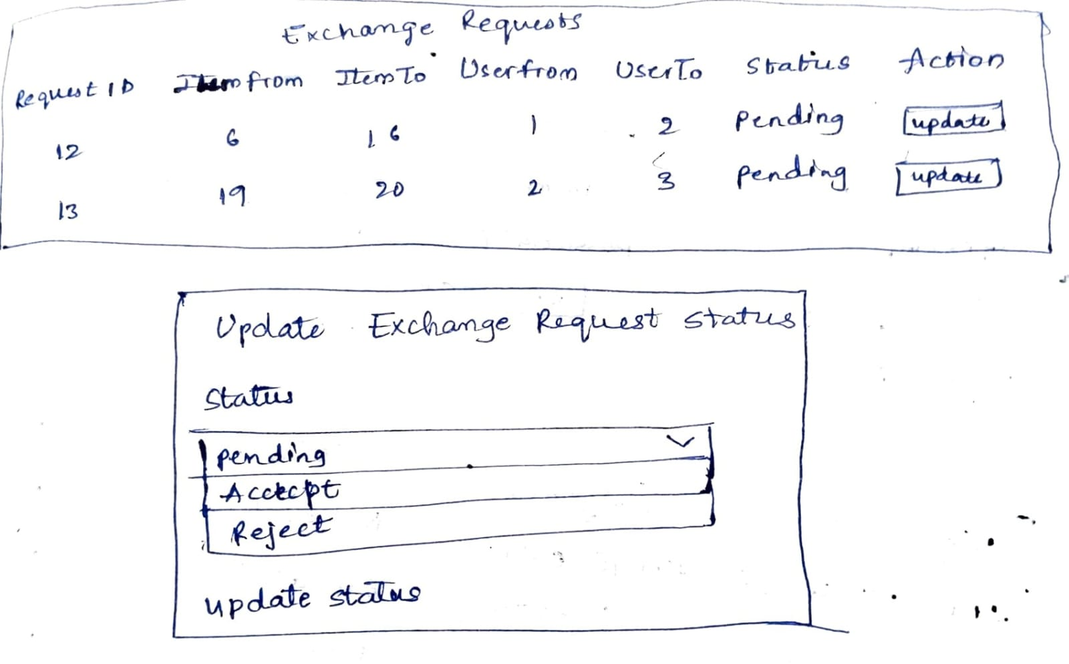

**IMPLEMENTATION AND EVALUATION:**

**Technologies Used**

* JSP is used to create dynamic user-facing web pages that display data.  
  Exchange requests, user authentication, registration, and item lists are all handled by JSP files like list-items.jsp, view-items.jsp, login.jsp, register.jsp, and create-exchange-request.jsp.  
  **Evaluation:** JSP makes it easier to integrate Java code in HTML, which enables the creation of dynamic content in response to database queries and user input. It is perfect for developing user interfaces that are dynamic and interactive.
* **Servlets:** Servlets are the controller in the Model-View-Controller (MVC) architecture; they manage HTTP requests and answers.  
  Examples are the item listing AddListingServlet, RegisterServlet, loginServlet and ViewItemsServlet the exchange request status update UpdateRequestServlet.  
  **Evaluation:** Servlets handle the application's business logic, handling user inputs, communicating with the database via DAO classes, and choosing which JSP page to present the outcomes on. They offer a clear division of labour between business logic and presentation.
* **JDBC (Java Database Connectivity)**: In order to manage database interactions and allow the platform to run SQL queries and obtain or update data, JDBC is utilised.  
  Database processes pertaining to items and user-item interactions are managed by Data Access Objects (DAO), such as ItemDAO and UsersItemsDAO, InterestRequestDAO for accessing table data  
  **Evaluation:** JDBC offers a simple API for managing transactions, running queries, and establishing connections to relational databases. Database access logic is encapsulated using DAO classes, which encourages code reuse and maintainability.
* **Weka**: Weka (Waikato Environment for Knowledge Analysis) is a Java-based machine learning software suite for data mining tasks, including classification, regression, clustering, and visualization.

**Development Process:**

The primary goal of the Web Application, Mary's Exchange Agency platform, is to develop an online shopping platform where users may offer things for trade, examine other users' listings, and plan exchanges.  
  
As part of the project creation, I used Visual Studio Code and Tomcat as the server. I established a Java project called "Exchange Agency" and added Maven dependencies to it.  
  
Based on the semester's course topic, I began by creating.java and.jsp files for UserDAO, ItemDAO, and ExchangeRequestsDAO to control database access. I also created Servlets such as AddListingServlet, ViewListingServlet, UpdateListingServlet, DeleteServlet, ListItemsServlet, and LikeItemServlet, among others, which used Java and JDBC to make database connections.

For front-end development, I generated login.jsp, register.jsp, addlisting.jsp, list-items.jsp, update-listing.jsp, and other JSP files, which were appropriately implemented using JSTL (JavaServer Pages Standard Tag Library).  
  
After creating all of the relevant Java and JSP files, I correctly mapped them in the web.xml configuration file. Using the Tomcat server, I deployed the project to Tomcat localhost and successfully launched the application.

For classification report, it including metrics like accuracy, precision, recall, F1-score, and the confusion matrix, provides a comprehensive evaluation of a classification model. It helps in understanding the model's performance across different classes, balancing trade-offs between precision and recall, and identifying areas where the model may need improvement.

**EVIDENCE OF IMPLEMENTATION:**

